

TECHNICAL UNIVERSITY OF KENYA

FACULTY OF APPLIED SCIENCES AND TECHNOLOGY

SCHOOL OF COMPUTING & INFORMATION TECHNOLOGY

SPECIAL/SUPPLEMENTARY EXAMINATION SERIES

FIRST SEMESTER EXAMINATIONS 2019/2020

THIRD YEAR EXAMINATIONS FOR THE DEGREE OF

BACHELOR OF TECHNOLOGY IN COMPUTER TECHNOLOGY

BACHELOR OF TECHNOLOGY IN INFORMATION TECHNOLOGY

BACHELOR OF TECHNOLOGY IN COMMUNICATIONS AND COMPUTER NETWORKS

ECII 3107/ECSI 3107/ECCI 3107: COMPUTER GRAPHICS

TIME: 2 Hours

Instructions to candidates:
This paper consists of FIVE Questions.

Answer Question ONE [30 Marks] and any other TWO Questions [20 Marks Each].

Write your college number on the answer sheet.

This paper consists of 4 printed pages

Page 1 of 4
QUESTION ONE (30 MARKS) COMPULSORY
- Differentiate between: (10 Marks)
- GKS and CGI
- Frame buffer and resolution
- glutInit(int *argc, char** argv) and glutCreateWindow(char *name)
- PHIGS and CGM
- Pixmap and Bitmap
- Explain the following colour schemes (6 Marks)
- RGB
- CMY
- HSV
- Given a point a line A(2,4) and B(3,3), find the image under the following transformations (6 Marks)
- Rotation through the angle 60 and centre (0,5)
- Reflection of the line y=-2x + 2
- Write an OpenGl sectional code to produce the following (8 Marks)
- Rectangle

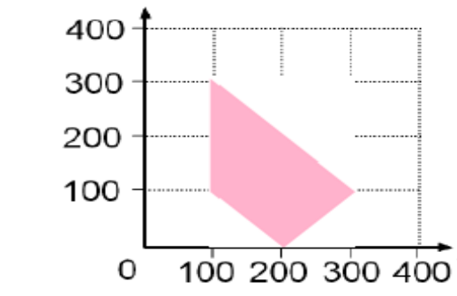
QUESTION TWO (20 MARKS)
- Discuss the following using relevant examples
- Line clipping using Cohen Sutherland algorithm (6 Marks)
- Test clipping (6 Marks)
- Write an OpenGl code segment that will produce the shape shown below (6 Marks)
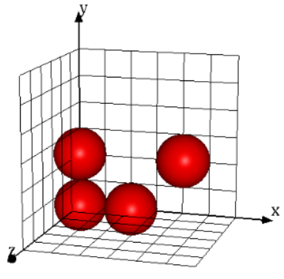 page 2 of 4
- State two features in OpenGL (2 Marks)

QUESTION THREE (20 MARKS)
- Explain four attributes of an object that may change during transformation and the kind of transformation that may cause such changes (8 Marks)
- Explain the following terms (6 Marks)
- Key frame animation
- Inverse kinematics
- Image Morphing
- Draw the shape produced by the sectional code below (6 Marks)
GLfloat p1[3] = {0,0,1};
GLfloat p2[3] = {1,0,1};
GLfloat p3[3] = {1,1,1};
GLfloat p4[3] = {0,1,1};
glBegin(GL_POLYGON);
glVertex3fv(p1);
glVertex3fv(p2);
glVertex3fv(p3);
glVertex3fv(p4);
glEnd();
QUESTION FOUR (20 MARKS)
- Explain the following abstractions in OpenGl (6 Marks)
- GLUT
- GLU
- GL
- Explain the application of computer graphics in virtual reality and simulation (4 Marks)
- Develop the DDA line drawing algorithm to draw a line P1(x1,y1) and P2(x2,y2) (5 Marks
- Given is a function drawHouse() which draws a wire frame house in the xy-plane as shown in the image below. On the same axis draw the scene produce by the code below. (5 Marks)
glPushMatrix();
glScalef(-1, 1, 1);
drawHouse();
glPopMatrix();
glRotatef(-90, 0, 0, 1);
glRotatef(-90, 0, 1, 0);
drawHouse();

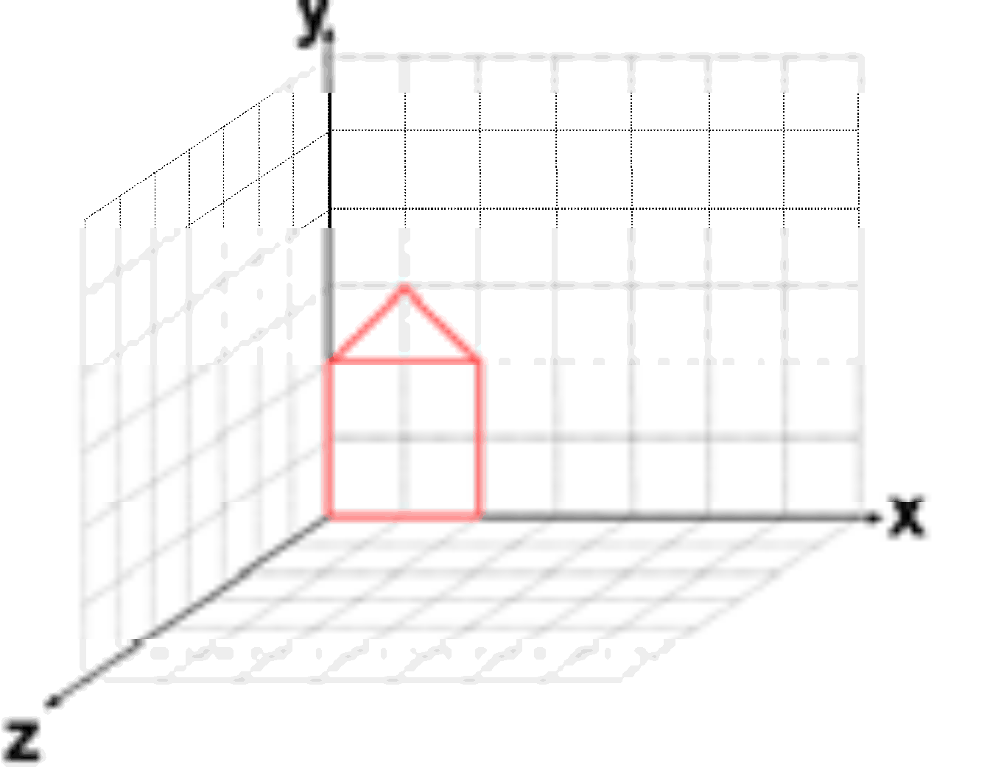

Page 3 of 4
QUESTION FIVE
- Draw the output of the OpenGl code given below (8 Marks)
#include <windows.h>
#include <GL/glut.h>
void initGL() {glClearColor(0.0f, 0.0f, 0.0f, 1.0f); }
void display() {
glClear(GL_COLOR_BUFFER_BIT);
glBegin(GL_QUADS);
glColor3f(1.0f, 0.0f, 0.0f);
glVertex2f(-0.8f, 0.1f); glVertex2f(-0.2f, 0.1f);
glVertex2f(-0.2f, 0.7f);glVertex2f(-0.8f, 0.7f);

glColor3f(0.0f, 1.0f, 0.0f);
glVertex2f(-0.7f, -0.6f);glVertex2f(-0.1f, -0.6f);
glVertex2f(-0.1f, 0.0f);glVertex2f(-0.7f, 0.0f);

glColor3f(0.2f, 0.2f, 0.2f);
glVertex2f(-0.9f, -0.7f);glColor3f(1.0f, 1.0f, 1.0f);
glVertex2f(-0.5f, -0.7f);glColor3f(0.2f, 0.2f, 0.2f);
glVertex2f(-0.5f, -0.3f);glColor3f(1.0f, 1.0f, 1.0f);
glVertex2f(-0.9f, -0.3f);
glEnd();

glBegin(GL_TRIANGLES);
glColor3f(0.0f, 0.0f, 1.0f);glVertex2f(0.1f, -0.6f);
glVertex2f(0.7f, -0.6f);glVertex2f(0.4f, -0.1f);

glColor3f(1.0f, 0.0f, 0.0f); glVertex2f(0.3f, -0.4f);
glColor3f(0.0f, 1.0f, 0.0f); glVertex2f(0.9f, -0.4f);
glColor3f(0.0f, 0.0f, 1.0f); glVertex2f(0.6f, -0.9f);
glEnd();

glBegin(GL_POLYGON);
glColor3f(1.0f, 1.0f, 0.0f);glVertex2f(0.4f, 0.2f);
glVertex2f(0.6f, 0.2f);glVertex2f(0.7f, 0.4f);
glVertex2f(0.6f, 0.6f);glVertex2f(0.4f, 0.6f);glVertex2f(0.3f, 0.4f);
glEnd(); glFlush();
}

int main(int argc, char** argv) {
glutInit(&argc, argv);
glutCreateWindow("Vertex, Primitive & Color");
glutInitWindowSize(320, 320);
glutInitWindowPosition(50, 50);
initGL();
glutMainLoop();
return 0;
}

- Explain various curves used in drawing in computer graphics (5 Marks)
- State the steps involved in the following stages of graphics
- Application Stage (4 Marks)
- Geometry Stage (3 Marks)

Page 4 of 4

